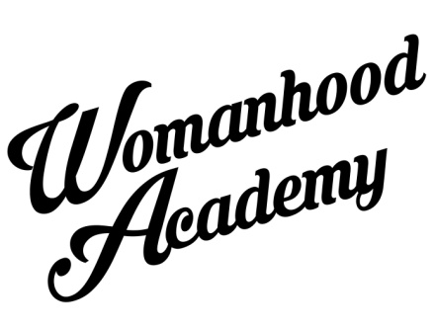
Womanhood Academy Female Empowerment Project
This summer project will incorporate the exploration of beauty and art, T-shirt designing and photography. We will go off site, so if the young ladies could bring their zip/oyster cards that will make it easier to travel.
Summer 2018 Application Form

First Name: Surname:

Age: DoB: Gender:

T-shirt size: XS [ ] S [ ] M [ ] L [ ] XL [ ]

Address:

Personal Phone: ICE Contact number:

My child can travel home alone Yes [ ] No [ ]
My child will be picked up by ……………………………. (insert name)
Contact details………………………………………………….. (if different from ICE)

Tell us in a few words, why you or your child would like to take part in the Womanhood Academy Summer Programme

We often use photographs, video footage for publicity and/or or screening purpose. I consent for photographs and video footage of my child to be used for publicity purposes.
Yes [ ] No [ ]
All Womanhood Academy records are stored under reasonable security and can only be accessed by Womanhood Academy staff. From time to time we may contact you regarding programmes or events. We will not pass on personal information.

Parent/Cares name Signature
Programme Costs:

Womanhood Academy Female Empowerment Project costs £50 for whole week.
Payment:
We are transitioning to a cashless payment system and asking for all fees to be paid in advance by accounts (BACS) transfer. We hope that this can make our on-the-day operations more efficient.

How to pay:
By BACS transfer direct into the Womanhood Academy bank account. In the payment reference section, start or reference ‘SS’ followed by your Childs full name. Please keep any notifications of confirmed payment transfer from your bank as proof of payment should we require it.
Here are the bank details;
Natwest Bank
Womanhood Academy
Account number 65251237
Sort Code 51-50-02

